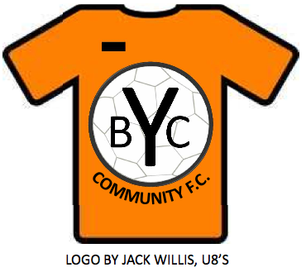
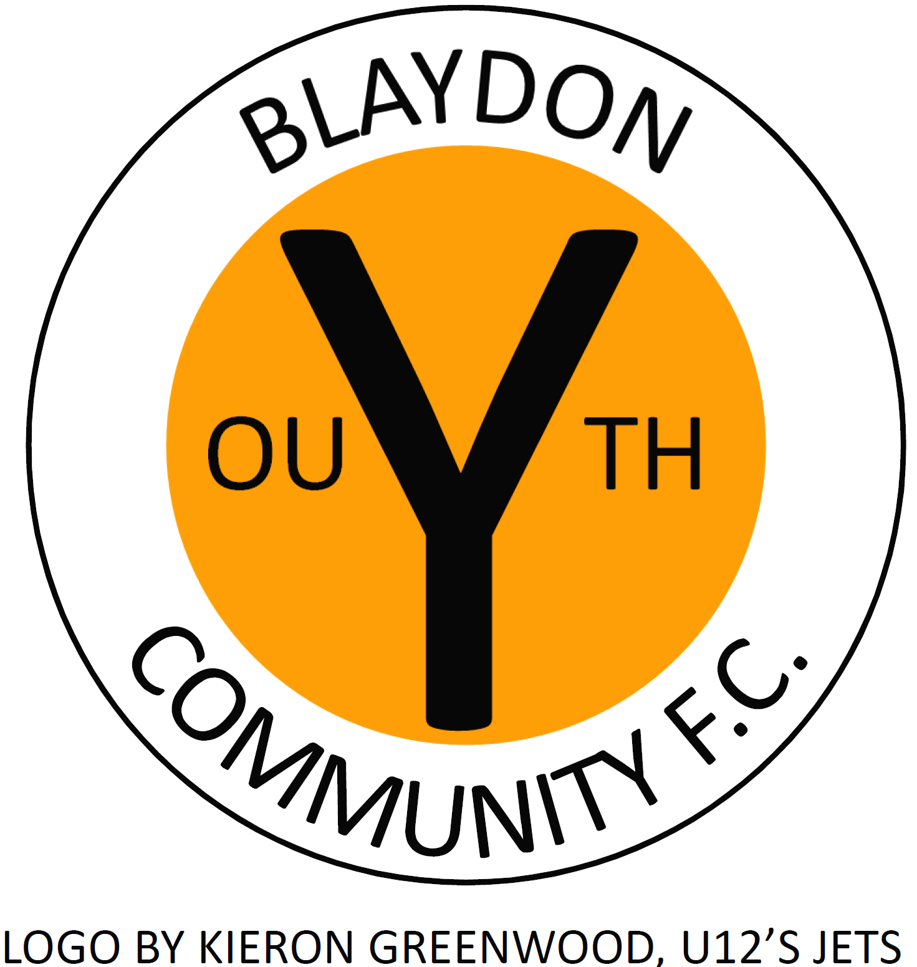

I, (please print your full name)………………………………………………………….

Address;……………………………………………………………………………...

…………………………………………………………………………………………..

Post Code………………..…

My child, ………………………………………………………………. will be participating in
the………………………………………………………… tournament/friendly.

I do understand that participation in this sporting event is a contact sport and that physical injury, including serious injury may occur.

I agree to accept any liability for personal injury arising out of my child’s participation in this event.

I hereby release any claim of any nature which I might have against Blaydon Youth Community Football Club or opposition from any liability for any injury incurred during this event.

Signature of Parent or Guardian…………………………………………………………
Date……………………..

Print name…………………………………………………………….

Please be aware that failure to complete this form, will mean that the player will not be permitted to play.

